Лабораторная №7 Анализ помех для разных типов антенн

1. 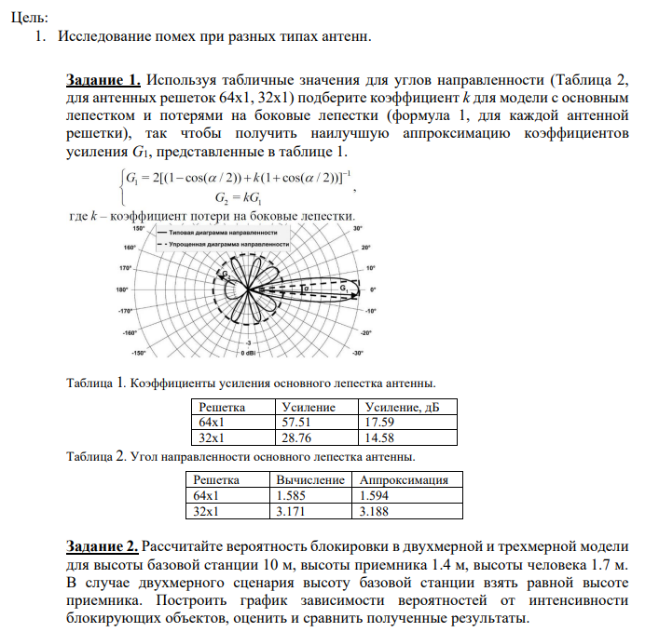
2. import matplotlib.pyplot as plt  
   import numpy as np  
     
   def get_k(G1, alpha):  
    return ((2 / G1) - (1 - np.cos(alpha / 2))) / (1 + np.cos(alpha / 2))  
     
   def get_G2(G1, k):  
    return G1*k  
     
   G1_64x1 = 57.51  
   G1_32x1 = 28.76  
     
   alpha_64x1 = 1.585*(np.pi/180)  
   alpha_32x1 = 3.171*(np.pi/180)  
     
   K_64x1 = get_k(G1_64x1, alpha_64x1)  
   G2_64x2 = get_G2(G1_64x1, K_64x1)  
   print(f"K при G1_64x1 = {K_64x1}, соответственно G2 = {G2_64x2}")  
   K_32x1 = get_k(G1_32x1, alpha_32x1)  
   G2_32x2 = get_G2(G1_32x1, K_32x1)  
   print(f"K при G1_32x1 = {K_32x1}, соответственно G2 = {G2_32x2}")  
     
   h_A = 10  
   h_U = 1.4  
   h_B = 1.7  
     
   lambda_b = np.linspace(0.1, 3, 100)  
   dist = 5  
   rad_b = 0.3  
   def prob_2d(lambda_b, rad_b, dist):  
    return 1 - np.exp(-lambda_b*2*rad_b*dist)  
   def prob_3d(lambda_b, rad_b, dist, h_A, h_U, h_B):  
    return 1 - np.exp(-lambda_b*2*rad_b*((dist*((h_B-h_U)/(h_A-h_U)))+rad_b))  
     
   probs_2d = []  
   for i in lambda_b:  
    probs_2d.append(prob_2d(i, rad_b=rad_b, dist=dist))  
     
   probs_3d = []  
   for i in lambda_b:  
    probs_3d.append(prob_3d(i, rad_b=rad_b, dist=dist, h_A=h_A, h_U=h_U, h_B=h_B))  
     
   plt.plot(lambda_b, probs_2d, label='Вероятности 2d')  
   plt.plot(lambda_b, probs_3d, label='Вероятности 3d')  
   plt.xlabel('Lambda')  
   plt.ylabel('Вероятность')  
   plt.title('Отношение вероятности к интенсивности блокатора')  
   plt.legend()  
   plt.show()

